**Probability and Statistics**

1. **Gaussian/Normal Distribution and its PDF(Probability Density Function)**

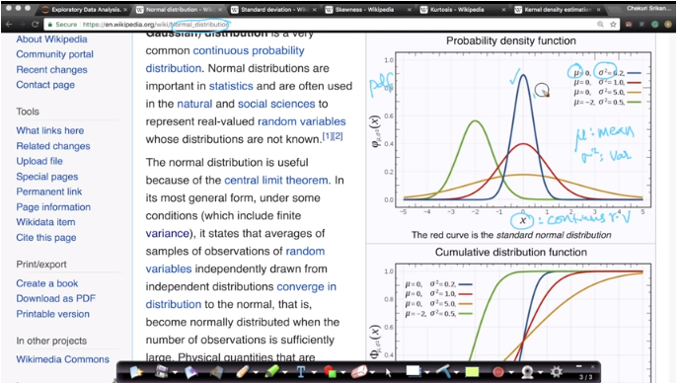

It explains the Gaussian Distribution with parameters Mean (mu) and variance (sigma square).

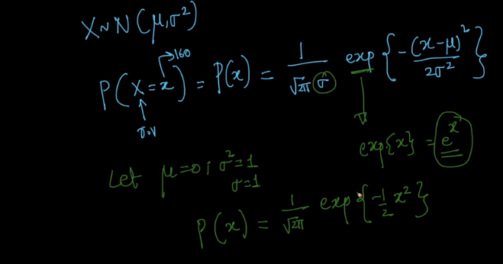

It explains the formula for PDF in gaussian distribution.

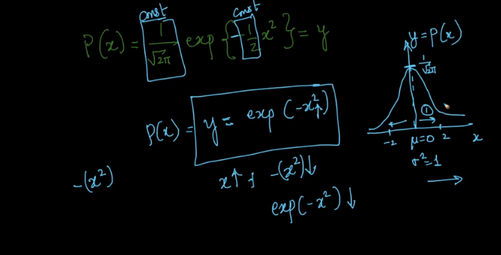

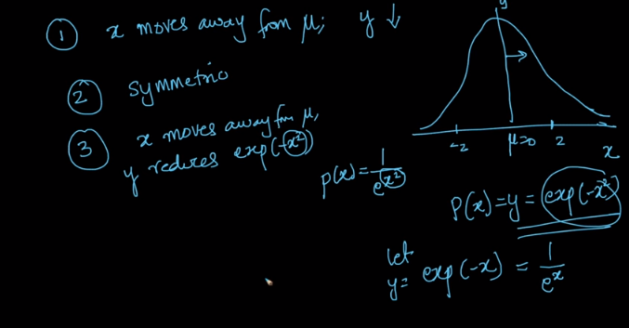

Conclusions drawn from the formula.

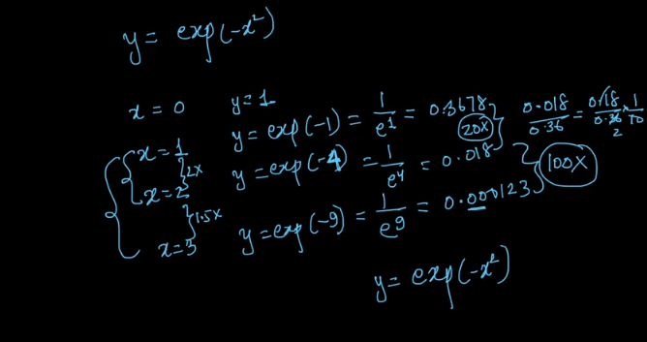

Example to explain the formula.

1. **CDF(Cumulative Distribution function) of Gaussian/Normal distribution**

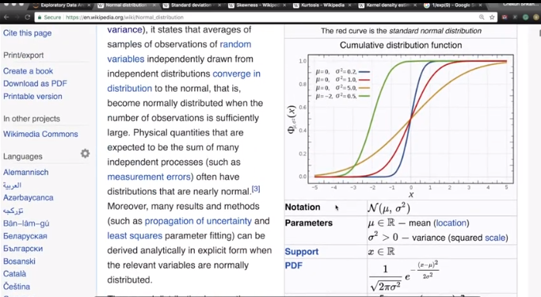

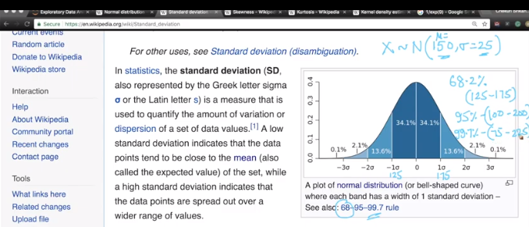

1. **Symmetric distribution, Skewness and Kurtosis**

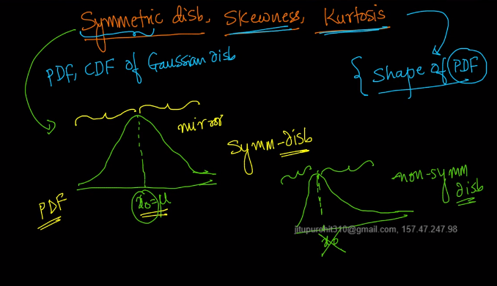

Symmetric distribution

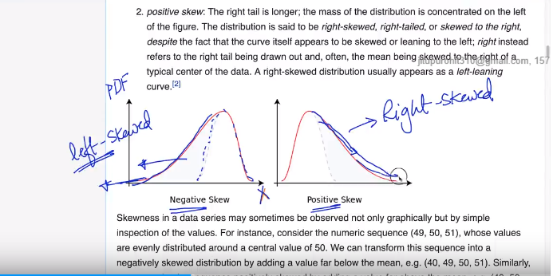

Skewness

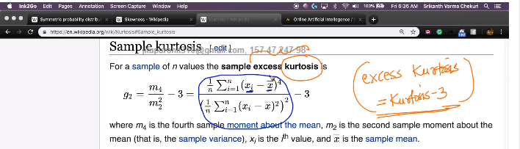

Kurtosis formula

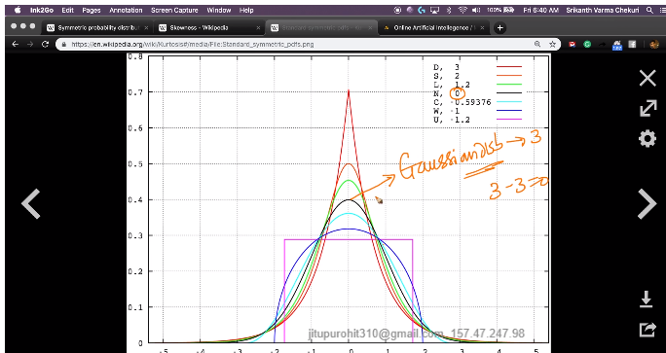

Distributions in Kurtosis

1. **Standard normal variate (Z) and standardization**

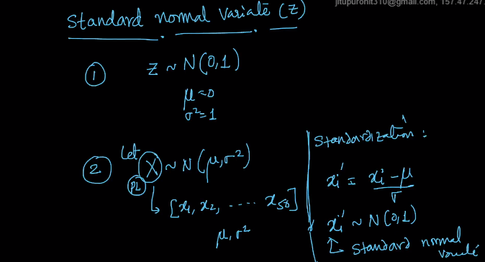

1. **Kernel Density Estimation (KDE)**

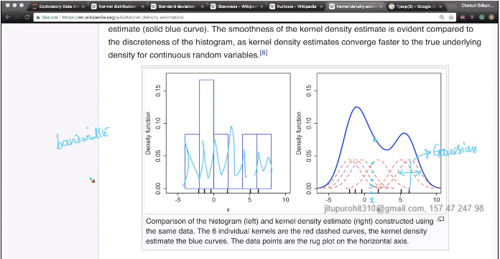

It explains how PDF is constructed using KDE. Refer notebook pg no.22.